Unit 2: Exercise 1
Match the activities with the pictures. Use the phrases in the box.

1. 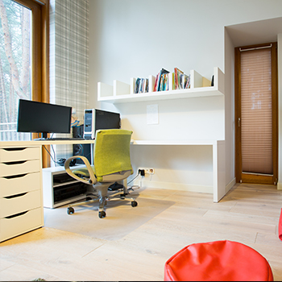
2. 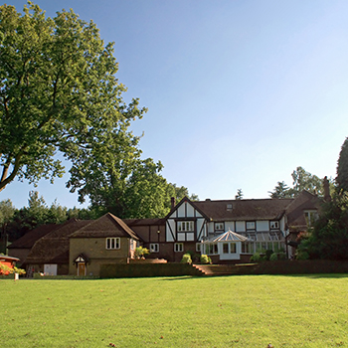
3. 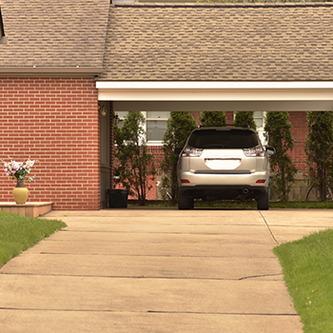
4. 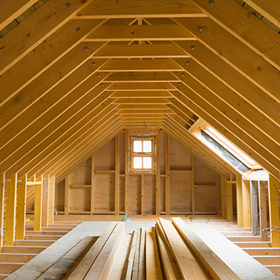
5. 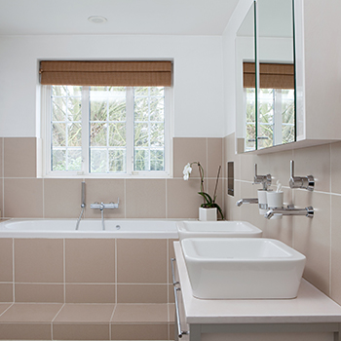
6. 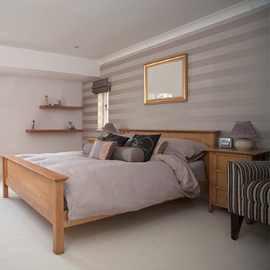
7.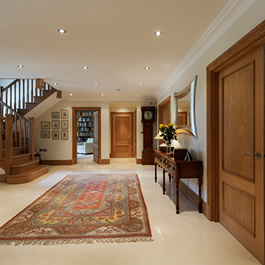
8. 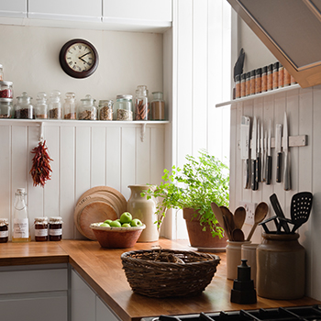
9. 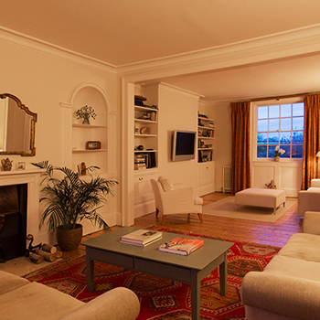

Unit 2: Exercise 2
Listen and choose the correct times, measurements, phone numbers and house prices you hear.

- 1:45 a.m.
- 11:45 a.m.
- 11:15 p.m.

- 505 m²
- 515 m²
- 550 m²

- 3759 296300
- 3759 256400
- 3759 296400

- 6½ kilometers
- 6½ metres
- 16½ kilometres

- 12:25 p.m.
- 12:35 p.m.
- 12:35 a.m.

- €416,500
- €460,500
- €465,000

- $230,555
- $230,565
- $213,555

- 0081 675231
- 0081 679231
- 0081 679321

Unit 2: Exercise 3
Listen to someone telephoning an estate agent’s to ask about a house for sale. Write the names of the people and places you hear being spelt. Remember to use capital letters.

- John _____________
- Denise ____________
- Newton in ___________
- _____________ Road
- Jerzy _____________
- Mary ___________

Unit 2: Exercise 4
Listen to an estate agent describing a house. Complete the notes. Choose the correct option for each answer.

This is a large detached house in a quiet street close to the centre of the village. You can walk to schools and shops, and the train station is only one and a half kilometres away. Last year, there was some building work which made the study and the dining room bigger, and the owners made the attic into an extra bedroom, so the total area of the house is now about 150 square metres; before it was only 120 square metres.
The house has four bedrooms so it’s a good size for a family with children. The largest bedroom has a private bathroom. One of the other bedrooms has a private shower room and the other two bedrooms have lots of cupboards. On the ground floor, apart from the hall, the study and the dining room, there’s a lounge, and a very big kitchen. There isn’t a large garden at the front of the house, but there’s a very pleasant, large, sunny garden at the back of the house where you can have barbecues in the summer. You can get to the garden through glass doors from the lounge. There’s no garage, but there’s enough space to park two cars on the road at the front of the house.
The owners have spent a lot of money on the house over the years and kept it in very good condition, so they’re hoping to sell it for about 350,000 euros. I agree, and I think this is a very good price …
- Last year the attic/dining room/study was converted into an extra bedroom.
- The area of the house is around 115/150/160 square metres.
- The largest bedroom has a private bathroom /a private shower room /lots of cupboards.
- The house has a large back garden/barbecue/front garden which is ideal for barbecues.
- The owners want to sell their house for €215,000/€350,000/€360,000 .

Unit 2: Exercise 5
Listen to the estate agent giving extra information about the house. Complete the table. Remember to use capital letters.

Viewing times
Monday to _________ : 9:30 a.m. – __________ pm
Saturday: ___________ a.m. – 4:00 p.m.
Friday and Sunday: no viewings
Contacts
Mark Smith
Telephone: 0073 ___________
Amanda ______________
Mobile: ______________
Office address
Main Office:
279 ____________ Road
Chesterford
CD3 9AG
Other Office:
35 Market Street
Chesterford
____________

Unit 2: Exercise 6
Listen and highlight the stressed syllable in each word. Practise saying the words.

STUDY
GARDEN
GARAGE
ATTIC
BATHROOM
BEDROOM
KITCHEN

Unit 2: Exercise 7

Match the words to make phrases.

Lamp floor block bathroom bed Wi-Fi

1.single
2.shared
3.ground
4.table
5.fast
6.apartment

Unit 2: Exercise 8
A student is looking for a flatmate. Read and listen to her advertisement. Practise saying the numbers.
Record yourself reading the script. Play to hear your answer.
My name’s Rachel and I’m a student. I’m in my 2nd year at Central School of Art. I live in a large flat in an apartment block in a quiet street in Princetown, only 2 km from the city centre.
The flat’s about 120 m². There are 3 bedrooms and I would like to rent one of them to another student. It’s a very big room, about 4.5 m wide and 6 m long. The flat has a shared bathroom, kitchen and lounge; it’s modern and comfortable and has fast Wi-Fi.
The price is €400 per month. If you would like more information, or if you would like to see the flat, please call me on 1896 320744.

Unit 2: Exercise 9
Put the words in the correct order to make questions.
What live house you of do in type
- _________ _________ _________ _________ _________ _________ _________ _________ ?
Like what do house about you your
- _________ _________ _________ _________ _________ _________ _________ ?
Live who with you do
- _________ _________ _________ _________ _________ ?
Your room which in your favourite is house
- _________ _________ _________ _________ _________ _________ _________ _________ ?
You where study do
- _________ _________ _________ _________ ?
Where quiet you is live it
- _________ _________ _________ _________ _________ _________ ?
To you music listen where do
- _________ _________ _________ _________ _________ _________?
Have double single or a bed do you
- _________ _________ _________ _________ _________ _________ _________ ?

Unit 2: Exercise 10
Listen to the questions. Record your answers. Play to hear your answers.

1. What type of home do you live in?

2. What do you like about your home?

3. Who do you live with?

4. Which is your favourite room in your home and why do you like this room?

5. Where do you study?
6. Is it quiet where you live?

